

Fully Flexible Credit - Debit System (FFCDS)

A Project Report

Submitted in fulfilment

In

**NETWORK AND INFORMATION SECURITY – ITE4001**

By-

|  |  |
| --- | --- |
| **Name** | **Registration Number** |
| 16BIT0155 | Pranjal Khandelwal |
| 16BIT0407 | Ritveak Dugar |

**Under the Guidance of**

**PROF: JEYANTHI N**

April, 2019

**ACKNOWLEDGEMENT**

In performing our project, we had to take the help and guideline of some respected persons, who deserve our greatest gratitude. The completion of this assignment gives us much Pleasure. We would also like to expand our deepest gratitude to all those who have directly and indirectly guided us in writing this assignment.

In addition, a thank you to Professor : JEYANTHI N who introduced us to the Methodology of work, and whose passion for the “underlying structures” had lasting effect.

Many people, especially our classmates and team members itself, have made valuable comment suggestions on this proposal which gave us an inspiration to improve our assignment. We thank all the people for their help directly and indirectly to complete our assignment.

PRANJAL KHANDELWAL

RITVEAK DUGAR

**CERTIFICATE**

This is to certify that the project work titled “Fully Flexible Credit - Debit System (FFCDS) " that is being submitted by RITVEAK DUGAR 16BIT0407, PRANJAL KHANDELWAL 16BIT0155 for NETWORK AND INFORMATION SECURITY (ITE4001) is a record of bonafide work done under my supervision. The contents of this Project work, in full or in parts, have neither been taken from any other source nor have been submitted for any other CAL course.

Place: Vellore

Date: 08 /04/2019

**Signature of the students:**

**Signature of faculty: (**JEYANTHI N**)**

1. **Abstract**

To avoid the hassle of cash payments inside campus, we are introducing the concept of Fully Flexible Credit - Debit System (FFCDS) using VIT ID card, which will help Vitians to pay for shops inside VIT. This works on the principle of access control, enabling students to pay using their own ID card authenticated by their secure pin.

To practicalize this idea we have following flow of events, first the user selects the store whom he/she wants to pay, which is followed by a secure login. The admin has the privilege to add user as well as to add money in user’s account.

1. **Model Description**

**Architecture**

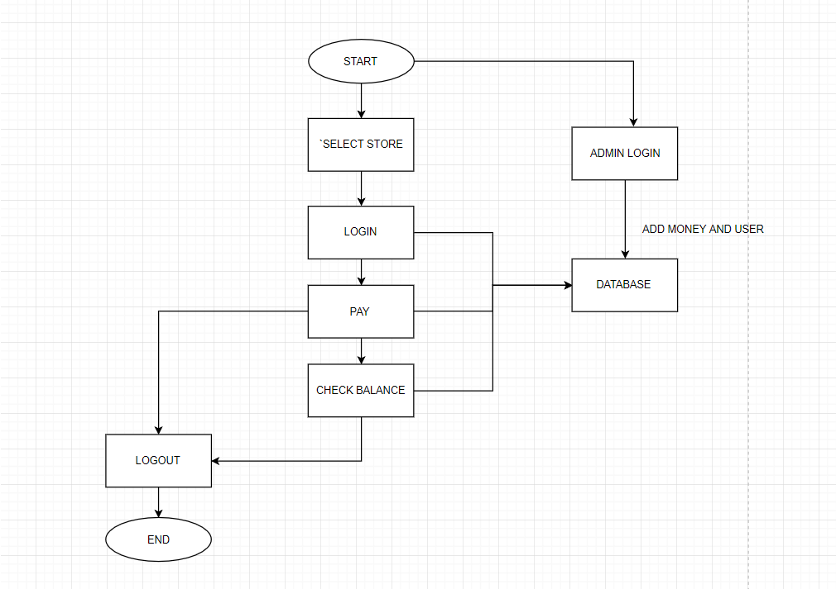

**Screenshsots**

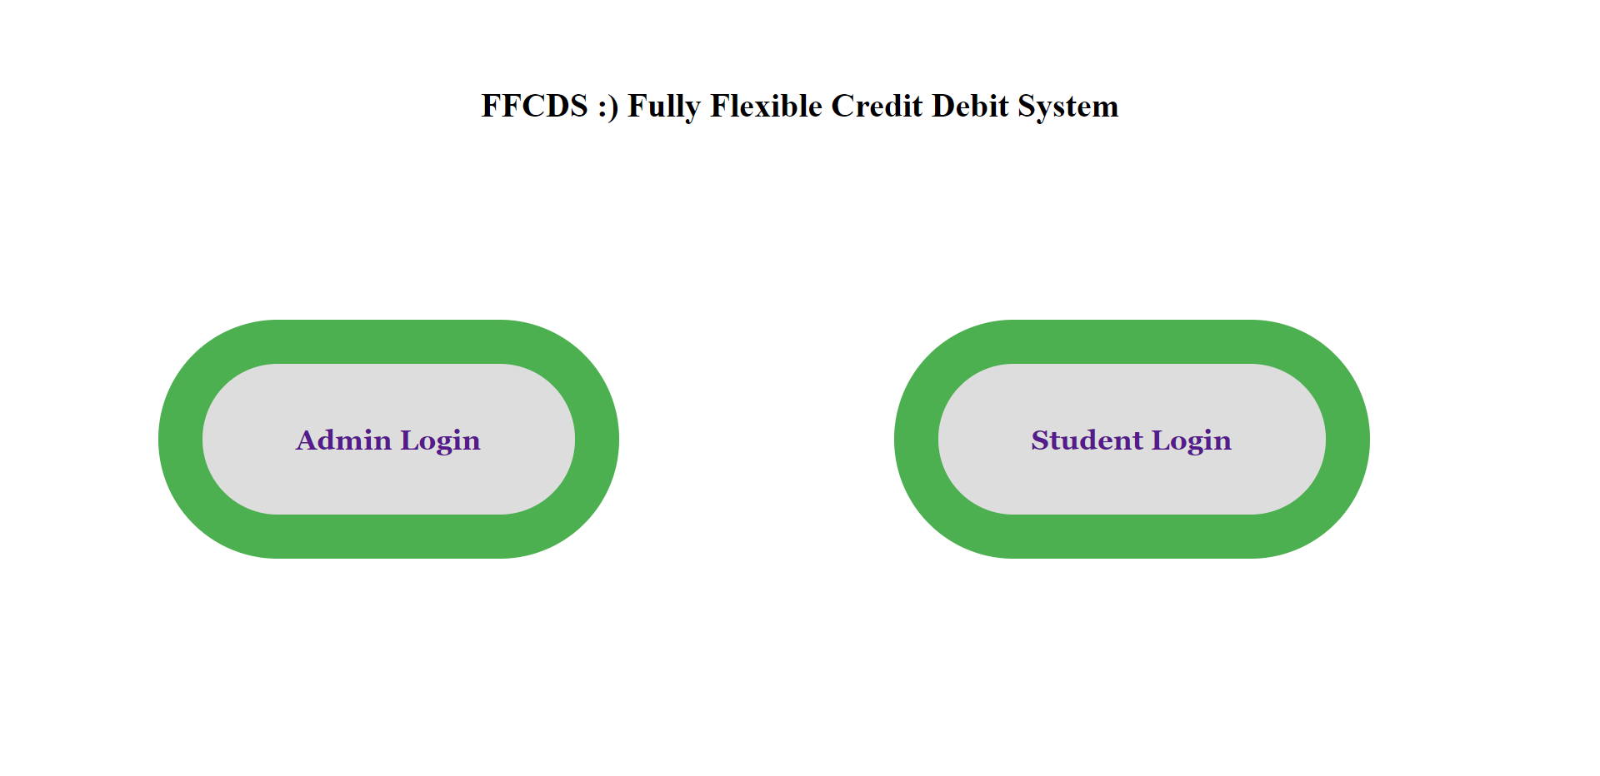

**Fig- 01 (Home Page)**

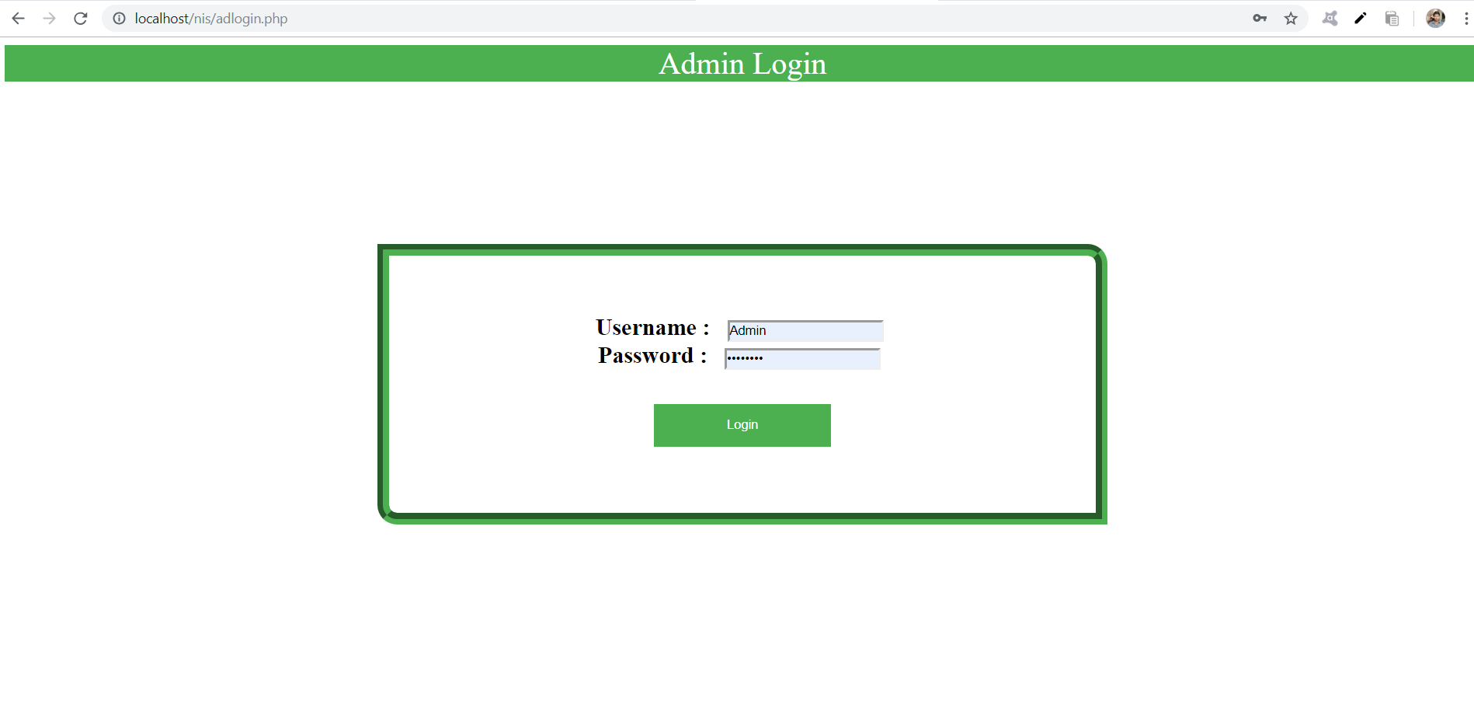

**Fig -02(Admin Login)**

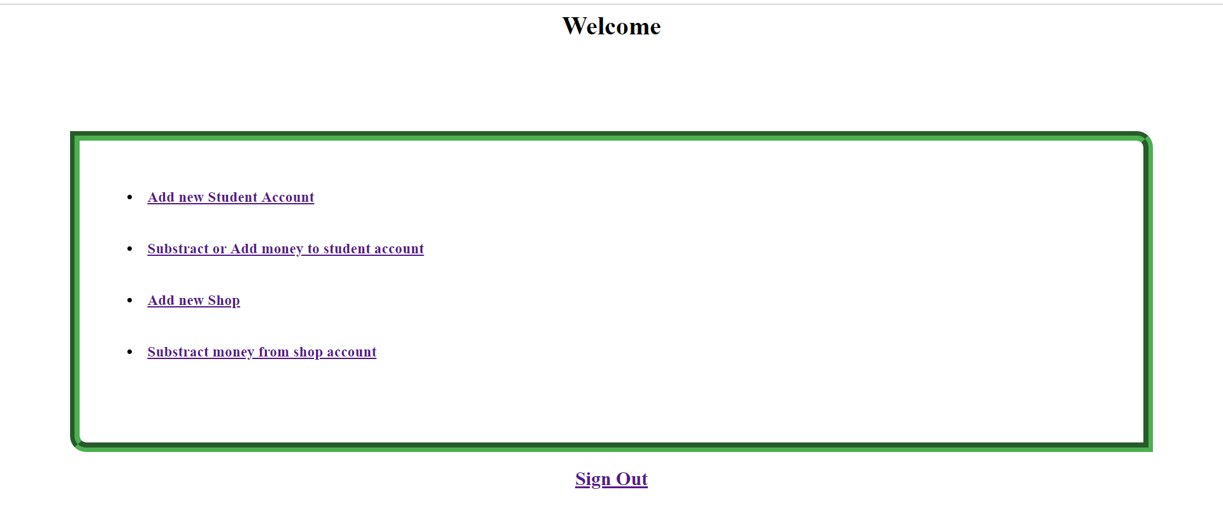

**Fig- 03(Admin Power)**



**Fig-04(Add New Student)**

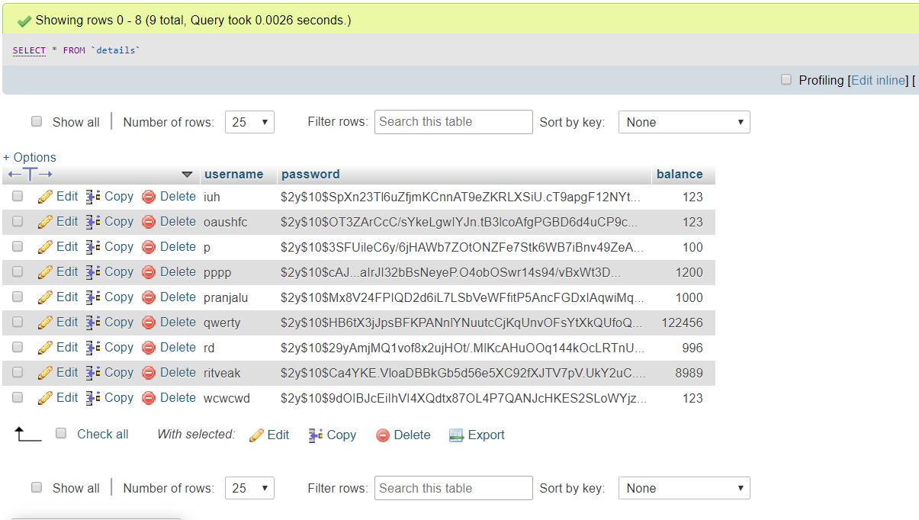

**Fig 05 (HASHED PASSWORD)**



**Fig-06(Subtract money from shop account)**



**Fig -07 (Student login and payment portal)**

**Conclusion:**

We created a payment system for Students inside campus relieving them from the hassle of carrying cash inside campus. We encrypted the whole system by session and implementing bcrypt algorithm for saving the passwords in our database hence making it a secure and reliable payment portal System for Students.